FAQs - Cloudflare ZTNA VPN

1. How to re-authenticate Cloudflare WARP 2
2- What are groups for Cloudflare ZTNA VPN 3
3- WARP Connectivity issues / WIFI connectivity 3
4- WARP still not Able to connect 4
5:- WARP certificate error 4
6:- HTTP Response Code 526 (Insecure Upstream. 5
7. User is not able to access the service but access is allowed in Cloudflare ZTNA 6
8. Application/services not working for user joined recently / added in AD group/company 6
9. Azure devops git requests are failing with dns resolving issues. 8
10. PostSharp Visual studio not able to register new license 10
11. Are Device Serial Number update in ZTNA Asset List 11
12. Internet not working sometimes when connected to cloudware warp agent 12
13: Cloudflare ZTNA document links 12
9. Azure devops git requests are failing with dns resolving issues. 14

1. How to re-authenticate Cloudflare WARP

Go to WARP Settings - Preferences - Account

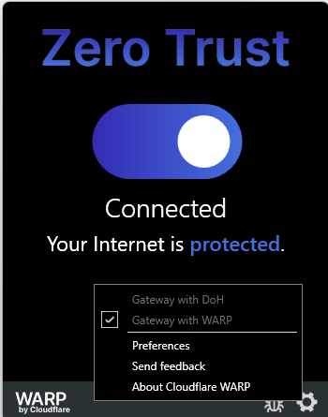

Click on Re-Authenticate to Clo
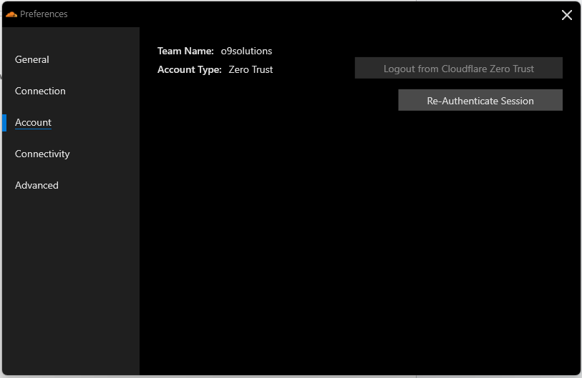

Login AzuerAD_SSO_ZTNA with your AD credentials
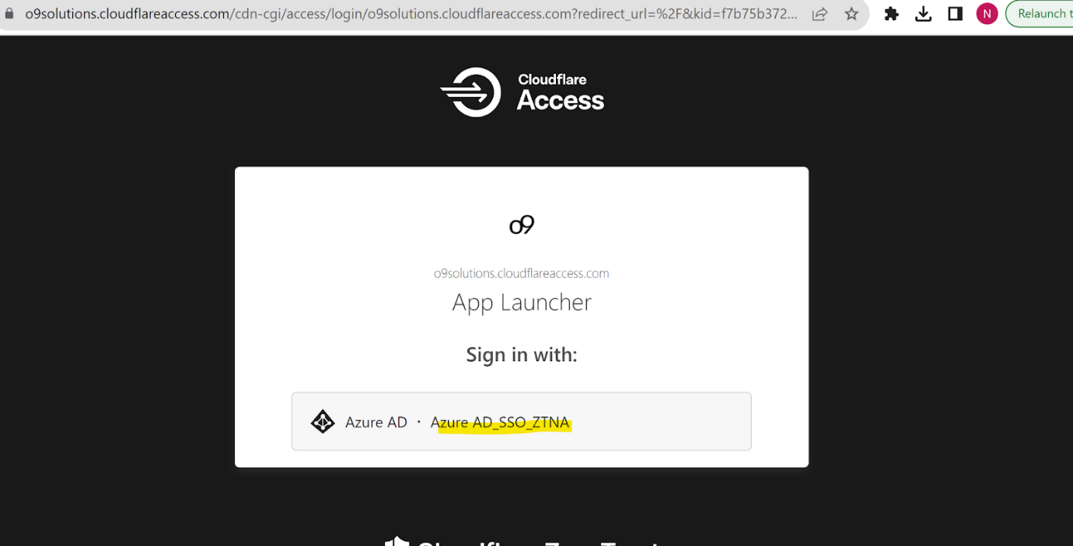

2- What are groups for Cloudflare ZTNA VPN

Ans: - below are the default User group to getCloudflare ZT VPN Access :-
- o9 Internal Employees (for all the .com users from the list) - ZTNACOMUsers.
- Partners/Customers( for all the .net users from the list) - ZTNANETUsers.

3- WARP Connectivity issues / WIFI connectivity

Ans: Check the Team name is set as “o9solutions” by going through the preference options. Reauthenticate if necessary and connect.
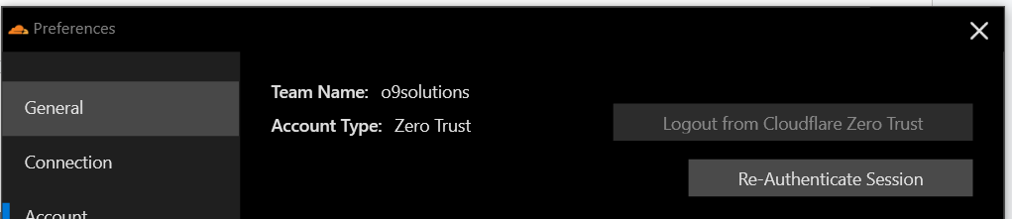

4- WARP still not Able to connect

Ans : Check below :

- Check if the user is registered and part of the AD group and the client is properly registered to the Team (o9solutions)
- Check if system is revoked in device due to inactivity or by admin activity
- More Details : Troubleshoot WARP Common Issues

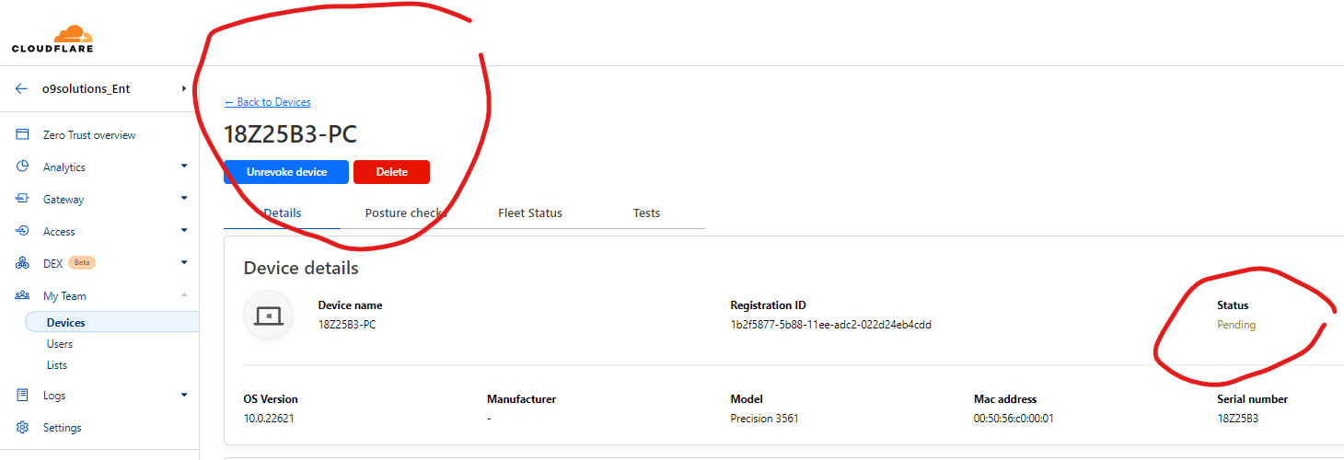

5:- WARP certificate error

Answer : Download the Cloudflare certificate.

To install the Cloudflare certificate in macOS, you can use either the Keychain Access application or a terminal. Both methods require you to download the Cloudflare certificate in .crt format.

- Open the .crt file in Keychain Access. If prompted, enter your local password.
- In Keychain, choose the access option that suits your needs and select Add.
- In the list of certificates, locate the newly installed certificate. Keychain Access will mark this certificate as not trusted. Right-click the certificate and select Get Info.
- Select Trust. Under When using this certificate, select Always Trust.
- The root certificate is now installed and ready to be used

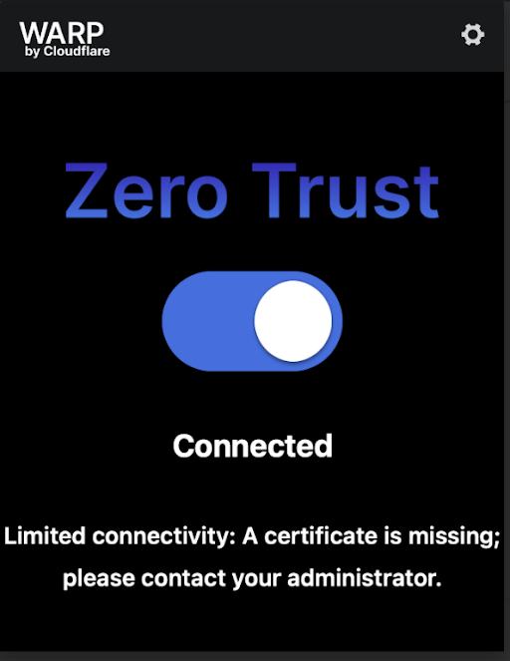

6:- HTTP Response Code 526 (Insecure Upstream.

Answer: A 526 error happens when WARP is unable to successfully validate the SSL certificate at the destination.
Solutions : Check if you are using FQDN instead of IP and URL certificate is valid (Not Self Signed or Expired)
- If above is not the case then, please reach our SecOps.

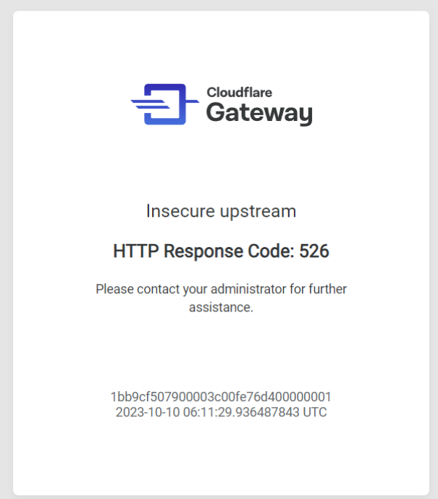

7. User is not able to access the service but access is allowed in Cloudflare ZTNA

Answer: If user is not able to access there could be following reasons

8. Application/services not working for user joined recently / added in AD group/company

Answer: If sophos vpn is present on your system, please uninstall the software & follow the below the steps
After checking policy and configuration try re-authenticating session

Go to Preference -> .Account -> Re-Authenticate Session

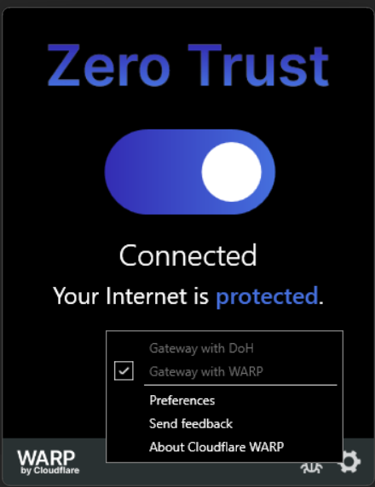

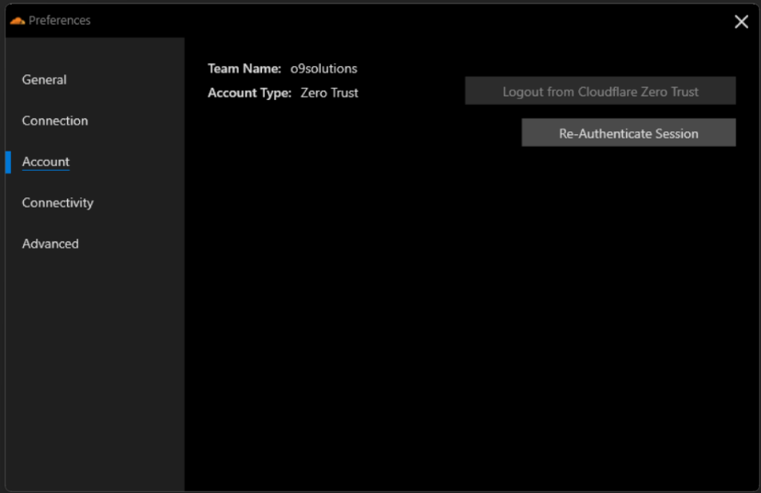

Please not once re-authentication is completed. Please wait for 20 to 30 mins to get it synchronized

9. Azure devops git requests are failing with dns resolving issues.
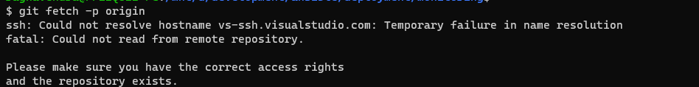
On further inspection, the DNS itself is not working in WSL. ping to google.com also not working.

Resolution:
If this issue is coming in wsl, then follow the below steps.
1. Create a file: /etc/wsl.conf.
2. Put the following lines in the file in order to ensure the your DNS changes do not get blown away
[network]
generateResolvConf = false

3. In a cmd window, run wsl --shutdown
4. Restart WSL2
5. Create a file: /etc/resolv.conf. #If it exists, replace the existing one with this new file.
6. Put the following line in the file
nameserver 8.8.8.8 # Or use your DNS server instead of 8.8.8.8 (Google DNS server)
7. Repeat steps 3 and 4. You will see git working fine now.

Credit: https://github.com/microsoft/WSL/issues/4285#issuecomment-522201021

In case of error :
Error: /etc/resolv.conf" E166: Can't open linked file for writing

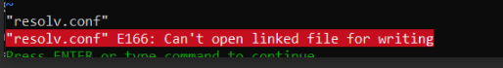

/etc/resolv.conf" E166: Can't open linked file for writing

if /etc/resolv.conf is a symbolic link, you won't be able to write it. If you want to overwrite the content in the file, remove the file and then create a new fi
- Remove symbolic link
sudo rm /etc/resolv.conf
- Write to new file. E.g.
sudo echo "nameserver 8.8.8.8" > /etc/resolv.conf

10. PostSharp Visual studio not able to register new license

Issue: Unable to build the code from VS using postsharp license.
Error: License key not installed

Resolution:

- Please remove the existing postsharp license from VS, then close all the VS sessions from the system

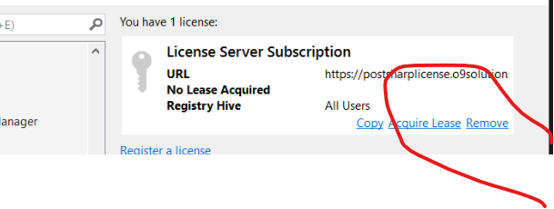
- Re-authenticate the ZTNA session by connecting to ZTNA warp agent, preferences - account - re-authenticate the session as shown in below screenshot

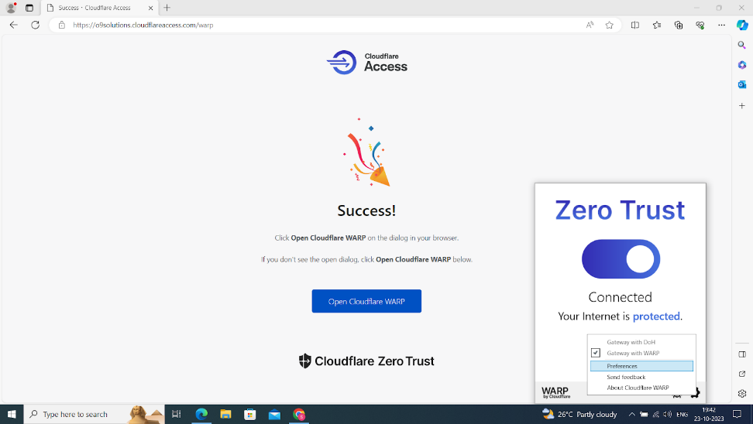

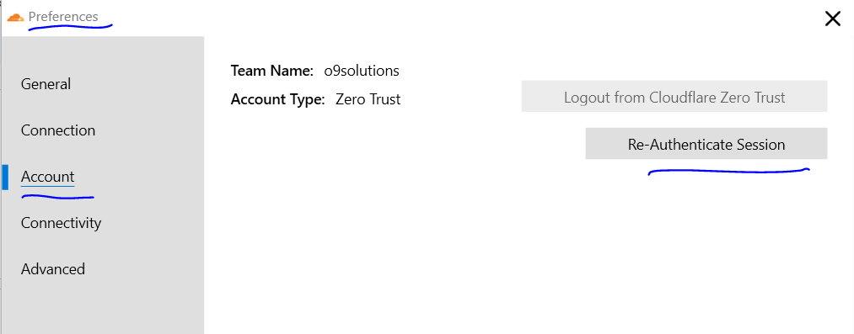

- Once re-authentication is successfully completed, please open the VS code & register the new postsharp license.
- Open the VS & run the Clean Session, then build the code & verify.

11. Are Device Serial Number update in ZTNA Asset List

Answer:

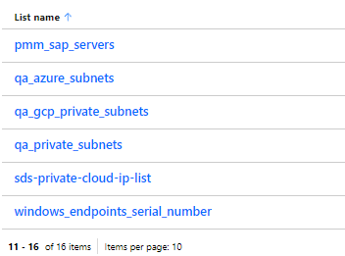

12. Internet not working sometimes when connected to cloudware warp agent

Answer: Whenever a warp agent gets connected, it will have its own network adapter & gets updated with DNS entries on IPv4 loopback address, but when it gets disconnected, it automatically removes it from IPv4 loopback DNS & changes it to automatically.

As a work around, please suggest the user to always turn off the warp agent by EOD.. So that internet issue won't happen when they try to connect from an office network or home network.

13: Cloudflare ZTNA document links

Answer : o9 SecOps site
https://sites.google.com/o9solutions.com/itsecurity/security-documents/cloudflare-zero-trust-vpn
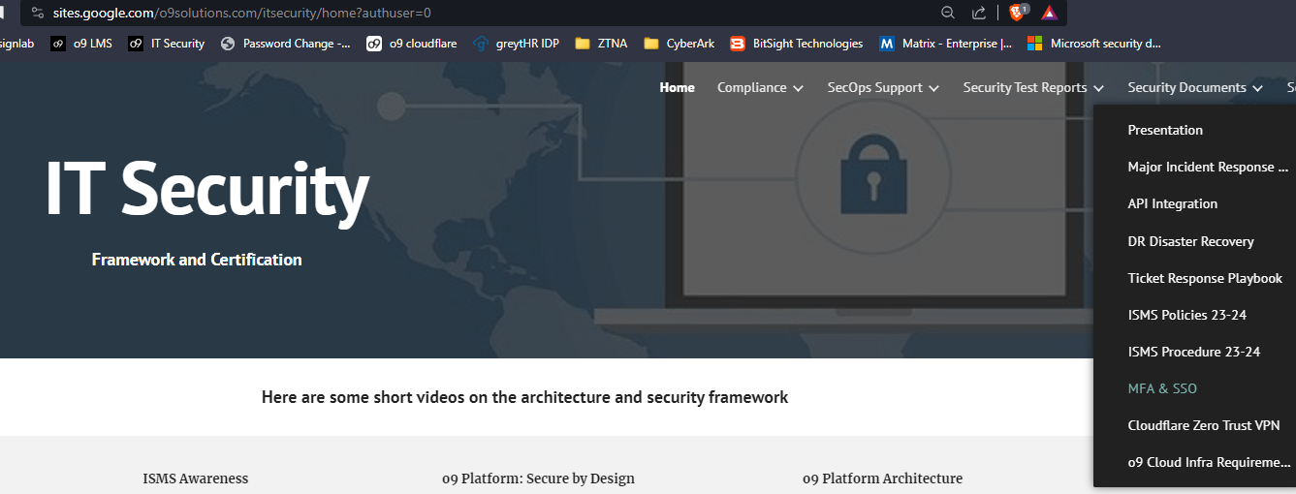

URLs:

https://help.teams.cloudflare.com/

14. Cloudflare to work with other ZTNA solution

Ans: Allow below firewall requirement from firewalls/Proxy

https://developers.cloudflare.com/cloudflare-one/connections/connect-devices/warp/deployment/firewall/

